- Approver Welcome Email from the Portal – requesting account to be activated
Remember to make a note of your user name and password.
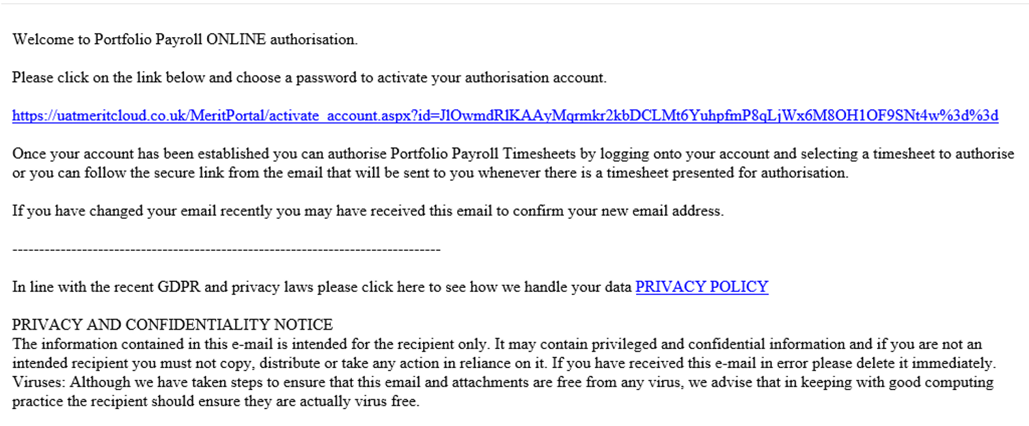
- Approver Home Screen:

- Approver Home Screen showing timesheets awaiting approval:
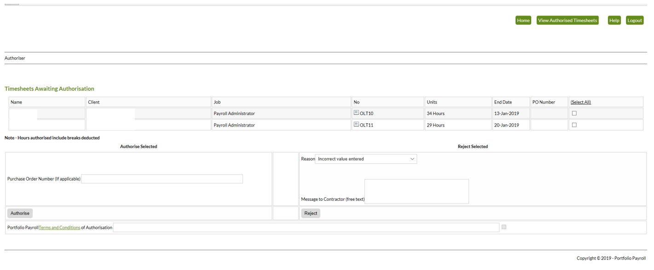
- To Authorise a timesheet, tick the box under “select all” against the timesheet you wish to approve. Enter a purchase order number in the box if applicable, click Authorise.
- To Reject a timesheet, tick the box under “select all” against the timesheet you wish to reject. Use the drop down arrow to select a reason for rejection of the timesheet. Enter your comments in the message to contractor box (if you wish), click Reject.
- Example email from the portal requesting approval of a timesheet:
If you click this link you will be logged into the online portal ready to approve the timesheet.
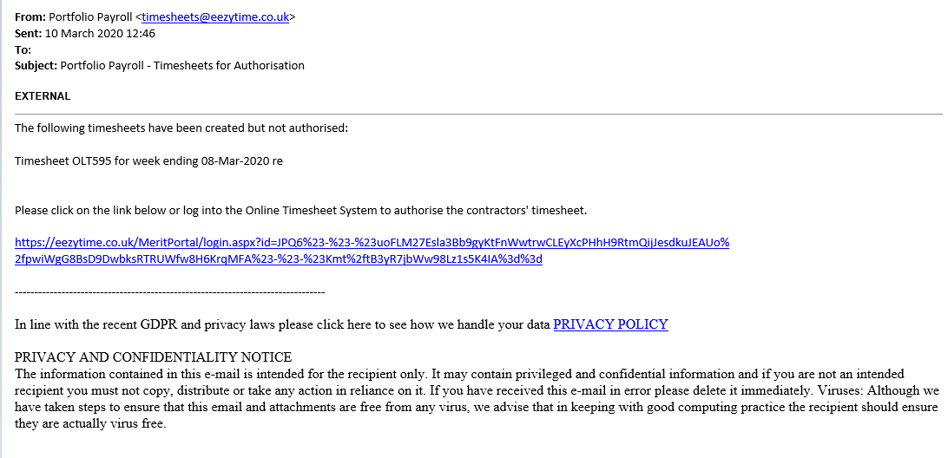
- Example reminder email from the portal requesting approval of a timesheet:
Note that reminders for approval of timesheets are sent to authorisers weekly on a Monday and a Tuesday. Only timesheets approved by 3pm each Monday are guaranteed to be paid that week.
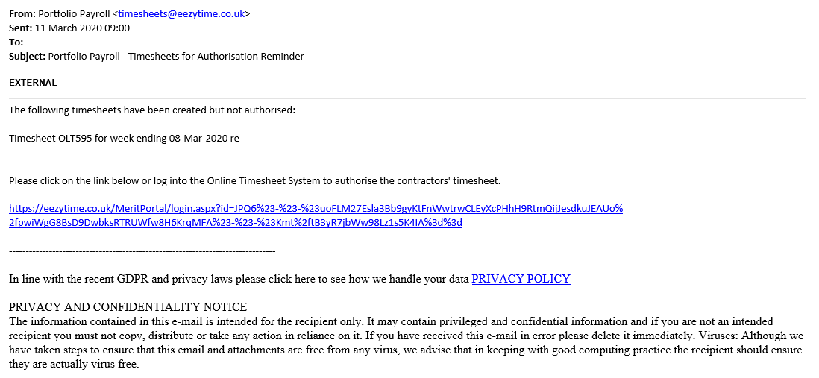
- Portal Web Address:
https://eezytime.co.uk/meritportal/login.aspx
You will need your user name and password to log in.

- Error Message on Log In
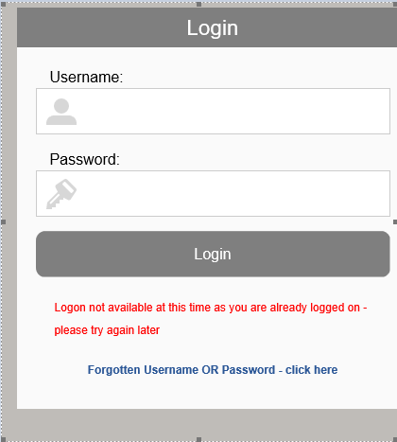

Some authorisers may find that they often receive an error message when they click on the approval link in an email – see above screen shot. This is due to link scanning on their email client. The link scanner works by following any links that are clicked and checking they are secure. As the link has the login credentials included in it then the link scanner logs in to the account. This means that when the authoriser follows the link shortly after there is already a login made.
The Portal does not allow logins from 2 different IP addresses within 15 minutes as a security feature. Since the link scanner is not running in the same location as the authoriser the IP address will be different and therefore an error is displayed.
To prevent this authorisers can go to https://eezytime.co.uk/meritportal/login.aspx and log in manually with their username/password. Remember to do this 15 or so minutes after you receive the timesheet approval email.

