Portal Guidance Notes
Contents

- Create a Weekly Timesheet
- Paye Workers – How should I request Holiday Pay?
- Ltd Co Workers – How should I submit my limited company invoice?

1. How to Create a Timesheet and Submit for Approval
- Log into the Portal
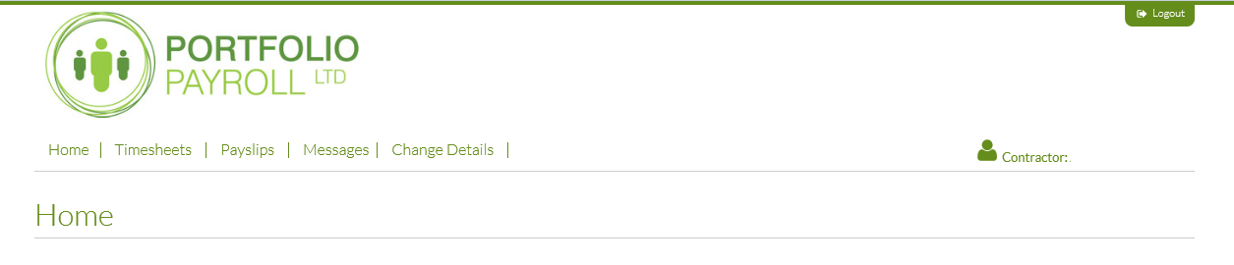
- Click on the Timesheets Menu Option
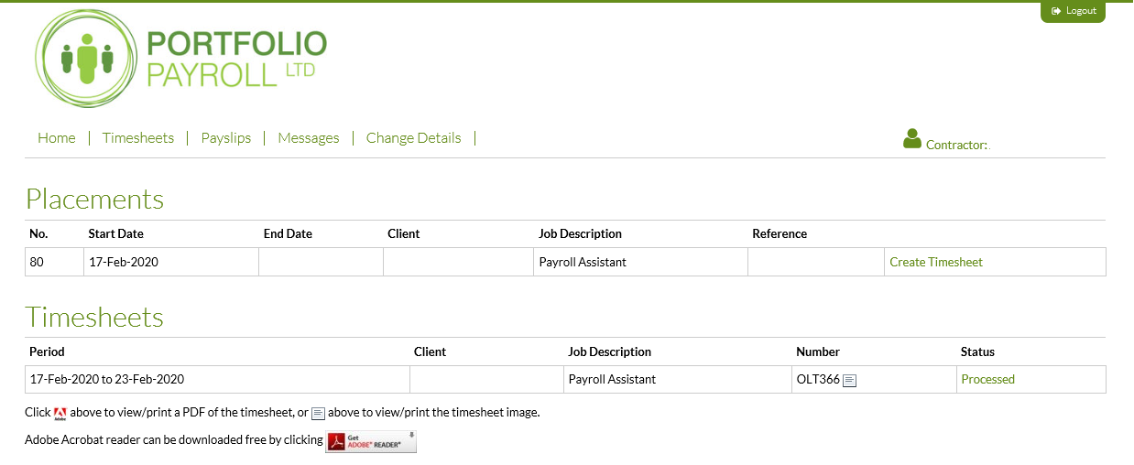
- Click on Create Timesheet
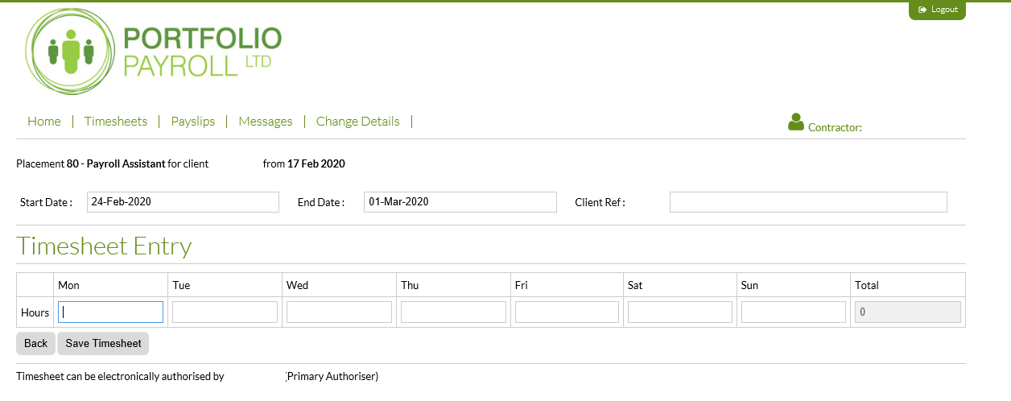

- You can change the start date of the working week by clicking in the start date box. A calendar will appear on screen. Click on the Monday of the working week you are creating a timesheet for.
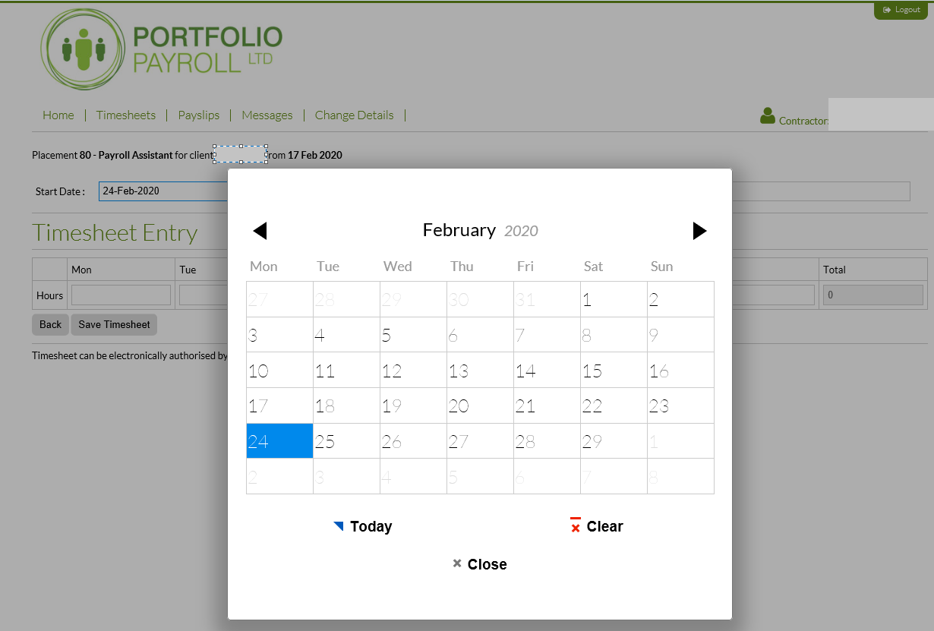

- If you are paid an hourly rate, enter the number of hours you worked each day in the boxes provided. If you are paid a daily rate enter 1 (Day) in each box against the days you worked.
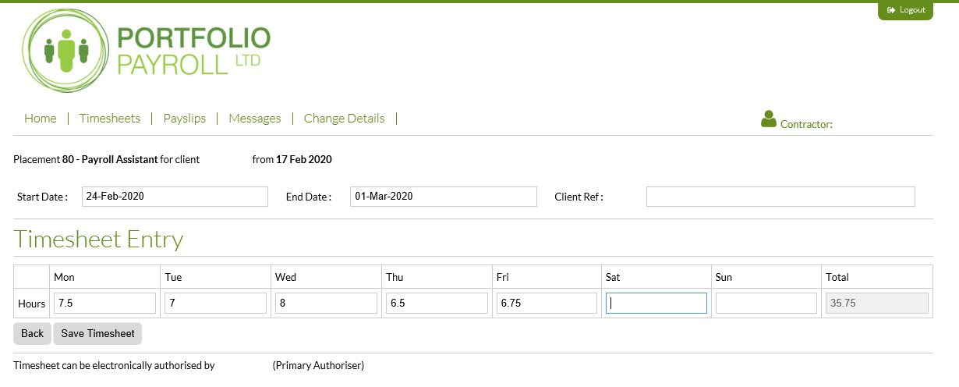
- Click Save Timesheet

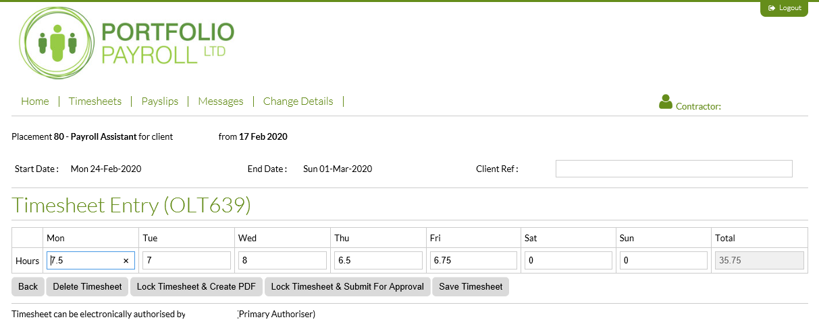
- Click Lock Timesheet and Submit for Approval
- The timesheet will now route automatically to the person shown on screen as your Primary Approver for authorisation.
- We can set up a secondary approver for you in case your primary approver is on holiday or otherwise absent. If you have a secondary approver they will also be shown on screen. If you would like a second approver to be added to your record please email Wages@portfoliopayroll.com with the name of your approver and their email address.
- Once your timesheet is approved the status of the timesheet will change to “Authorised Online”.
- Reminders for missing timesheets, or timesheets which have not yet been approved, will be sent to you weekly on a Monday and a Tuesday morning. Approved Online Timesheets received by 3pm each Monday will be paid in that week’s payroll.

2. Paye Workers – How should I request Holiday Pay?
- Holidays should be requested by emailing wages@portfoliopayroll.com.
- On the portal:
- If you are on holiday for only part of the week – create your timesheet as usual within the portal but put zero working hours (or zero days) in the timesheet for the days you are on holiday.
- If you are on holiday for the full working week – create your timesheet in the portal as usual for the week you return to work, but remember to change the week start date to the start of your new working week.

- Ltd Co Workers – How should I submit my limited company invoice?
1. Please continue to submit your limited company invoices to wages@portfoliopayroll.com.

